Introduction of POCT immunoassay analzyer ©

The product named “POCT” immunoassay analyzer or “PoLab” of “Portable Lab”. It includes following parts: test card, B-1 machine, C-2 machine and mobile phone APP. The product has achieved patents from America and China, and certificated by American Government and Chinese hospitals, and gotten the certification by Province Department of Science and Technology.

PoLab
  - C-2（to C 2.0）：
design sketch
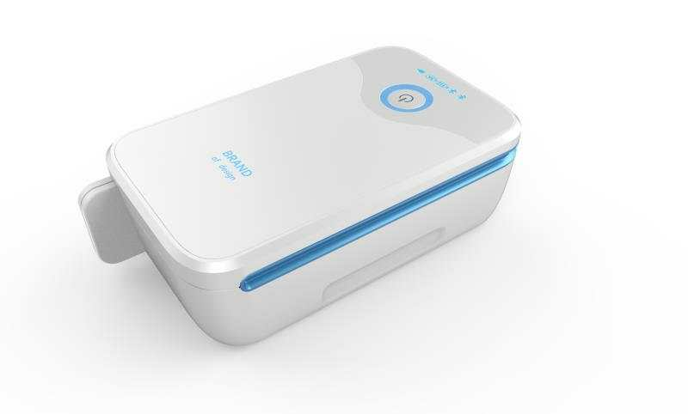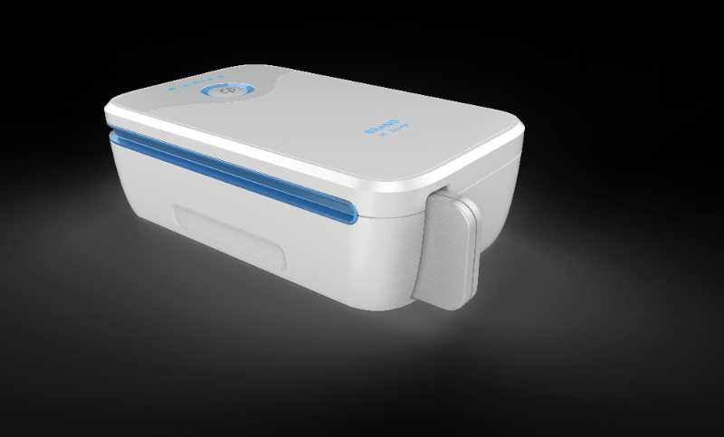
product overview: It’s semi-closed black box inside, the switch outside, connect with WIFI, inner camera and one-card slot. It can be used with normal smart cell phones, the result can be received within tens of seconds automatically. With the technology of Colloidal gold immunochromatography and patent image analysis, tens of clinical index can be tested, such as women, kidney, heart and cerebral vessels, liver, inflammation and so on.

First Use
Process:
.
Take urine or serum or whole blood with dropper in the vessel, dropped to area ”s” slowly until the strip appeared
Open WeChat, scan the analzyer to measure the bottom two-dimensional code of the analyzer, bind the analyzer
Open sealed foil pouch and take out the test card and the disposable dropper
Put the vessel with
specimen on the steady flat.
After dozens of seconds, the test report can be checked and viewed on the cell phones.
Insert the test card into the slot of the analyzer (Feeling feedback after inserting the stability)
Put the test card on flat
for 3-5min
Click “WIFE code”,
keep the light on
Open the WIFI of
cell phones
Turn on the switch

